PR REVIEW
SCC-4485 | Consumer Account GL Classification
GreatPlainsMerge | OmniStudio implementation and merge-readiness review
Environment | GreatPlainsMerge | 00DEa00000GkAsHMAV | Sandbox
Review date | 28 August 2026
Evidence | Live OmniStudio configuration | Account schema | Aggregate Account read-back
Decision | Request Changes - do not approve or merge
Boundary | PR review only; no deployment, activation, account creation, or org change

MERGE DECISION
Request Changes. The active pipeline has no MDU classification, hard-codes Segment as Residential, and does not populate Customer Type. The story cannot be approved in its current state.

Finding summary
Severity | Location | Result | Reviewer finding
P0 | SQ/OrderPipeline v5 | Blocker | CreateConsumerAccount always passes Segment = Residential; no MDU branch exists.
P0 | AccountCreation v1 | Blocker | No input/output mapping populates Account.Customer_Type__c with Consumer.
P1 | Version state | Changes | AccountCreation v1 is marked inactive while the active pipeline invokes it by bundle name.
P1 | Change isolation | Changes | The same mapper serves Consumer and Service Account actions; the PR must not broaden the new values to Service Accounts.
P1 | PR evidence | Blocked | No PR URL, branch, commit, or exported DataPack diff was supplied for line-by-line review.

Required implementation path
The PR should derive one MDU flag from the documented Place inputs, calculate the Account segment once, pass all three GL values into CreateConsumerAccount, and map them explicitly in AccountCreation.
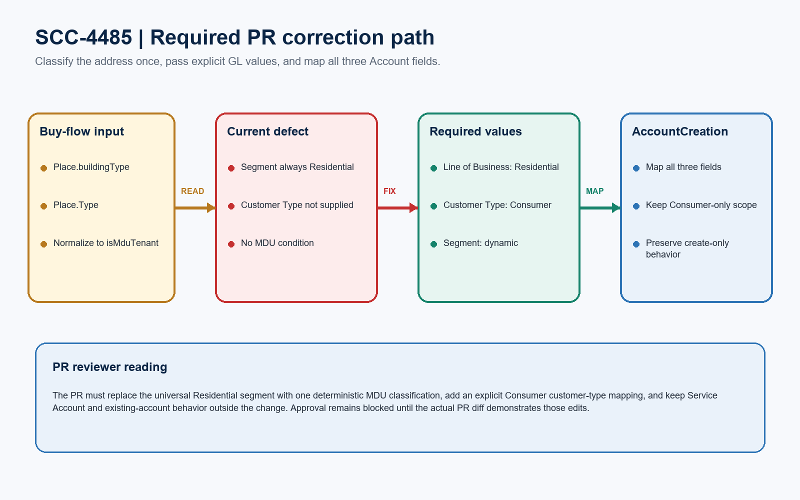
Figure 1. SCC-4485 required PR correction path
REVIEWER INTERPRETATION
The classification belongs before the Data Mapper call. AccountCreation should receive explicit, final values and map them without relying on Account defaults or implicit record-type behavior.

Detailed PR findings
ID | Severity | Component / location | Issue | Required modification
PR-01 | P0 | OrderPipeline v5 > Consumer Account action | additionalInput contains LineofBusiness = Residential and Segment = Residential. It contains no Place.buildingType, Place.Type, Unit, Multi-Family, or MDU condition. | Add deterministic MDU classification and pass a derived segment instead of the hard-coded universal value.
PR-02 | P0 | AccountCreation v1 > Account output | LineofBusiness maps to Line_of_Business__c and Segment maps to Segment__c. No mapping targets Customer_Type__c. | Pass CustomerType = Consumer and add CustomerType -> Account.Customer_Type__c.
PR-03 | P1 | Customer Type field default | The field default is Business, not Consumer, and recent Consumer Accounts are blank. A field default cannot satisfy this story. | Make the value explicit in the pipeline and mapper; do not depend on schema defaults.
PR-04 | P1 | AccountCreation version lifecycle | The only AccountCreation record found is Load v1 and IsActive = false. The ticket does not identify an active replacement. | Include the intended version/state change and prove SQ/OrderPipeline resolves to that version after merge.
PR-05 | P1 | Shared mapper and create semantics | CreateConsumerAccount and CreateServiceAccount both invoke AccountCreation. The Account Id output remains disabled, indicating create-only behavior. | Keep Customer Type and MDU Segment Consumer-only; do not enable Id/upsert behavior or update existing Accounts.
PR-06 | P2 | Component identity | The ticket calls the component SQ_OrderPipeline; the live key is Type SQ / SubType OrderPipeline, Name SQtoOrderPipeline, active v5. | Use the exact exported component key in the PR and review notes to prevent reviewing or packaging the wrong asset.

REVIEW CONCLUSION
PR-01 and PR-02 are merge blockers. The remaining findings control version safety, change isolation, and reviewability and should be resolved in the same PR.

Required PR modifications
Change area | Current implementation | Required PR content
MDU classifier | No classifier is referenced | Create isMduTenant from buildingType in {MDU, MDU Tenant, Multi-Family} OR Place.Type = Unit.
Derived Segment | Residential for every Consumer | Set AccountSegment to MDU Tenant when isMduTenant is true; otherwise Residential.
Consumer inputs | LineofBusiness and Segment only | Pass LineofBusiness = Residential, CustomerType = Consumer, and Segment = AccountSegment.
Data Mapper | Maps Line of Business and Segment | Add CustomerType -> Customer_Type__c; retain existing Line and Segment mappings.
Scope guard | Shared mapper | Apply new classification inputs only under the Consumer record-type branch; preserve Service Account inputs.
Create-only guard | Account Id output disabled | Keep Id/upsert mappings disabled so existing accounts remain outside SCC-4485.

Implementation shape
PSEUDOCODE - ADAPT TO OMNISTUDIO FORMULA SYNTAX
isMduTenant = allowed buildingType OR Place.Type equals Unit; AccountSegment = IF(isMduTenant, MDU Tenant, Residential); CreateConsumerAccount inputs = Residential / Consumer / AccountSegment.

PR merge checklist
# | Merge check | Status
1 | Pipeline diff removes universal Residential segment | Required
2 | Mapper diff adds Customer_Type__c mapping | Required
3 | Consumer-only scope is explicit | Required
4 | AccountCreation active/version target is unambiguous | Required
5 | PR or exported DataPack diff is attached for re-review | Blocked

Review evidence and limitations
Evidence source | Confirmed result
Target org | GreatPlainsMerge | Great Plains Communications | 00DEa00000GkAsHMAV | Sandbox
Active pipeline | SQ / OrderPipeline | SQtoOrderPipeline v5 | active | 7 active elements
Data Mapper | AccountCreation | Load v1 | inactive | 46 items
Account fields | Line_of_Business__c, Customer_Type__c, Segment__c; required picklist values exist
Current outcome signal | 64 Consumer Accounts since 12 August: Residential / blank / Residential; 8 created by Heroku Applink Service
Configuration search | No MDU, buildingType, Multi-Family, Unit, Place, or CustomerType logic in active pipeline elements

REVIEW LIMITATION
No repository PR URL, source branch, commit, or exported DataPack diff was provided. This is a PR-readiness review of the live configuration, not a claim that a specific code diff was inspected.

Ready-to-paste PR review comment
PR COMMENT
Request Changes for SCC-4485. In active SQ/OrderPipeline v5, CreateConsumerAccount still passes LineofBusiness = Residential and Segment = Residential for every Consumer Account and contains no MDU classification. AccountCreation maps Line of Business and Segment but has no mapping to Customer_Type__c; the field default is Business and recent Consumer Accounts are blank. Update the PR to derive one isMduTenant flag from the documented Place values, pass Segment as MDU Tenant or Residential accordingly, pass CustomerType = Consumer, and add the Customer_Type__c mapping. Keep the change Consumer-only, preserve Service Account inputs and create-only behavior, and include the exact SQ/OrderPipeline plus AccountCreation DataPack diff and intended active version for re-review. No deployment, activation, account creation, or org write was performed during this review.

